Project Documentation: VisionDecor AR (with Lumina-Sync AI)
Internship Task 4: High-Fidelity AR Interaction Design.
1. The Vision
The objective was to design an Augmented Reality (AR) interface that feels integrated into the user's physical space. Most AR apps feel like a "sticker" on a screen; VisionDecor AR aims to feel like a window into a redesigned room.
2. The "Extra Feature": Lumina-Sync AI
To push this project beyond a standard UI mockup, I implemented the Lumina-Sync AI feature:
- What it does: It simulates an environment scan that detects the room's ambient light temperature and wall colors.
- User Value: It removes the guesswork of "will this blue sofa match my cream walls?" by automatically adjusting the virtual model's texture and shadows to match the specific room's data.
3. Key Interaction Elements
A. The Spatial Reticle (Intuitive UI)
- Interaction: A dashed elliptical indicator that follows the floor plane.
- Intuition: It provides immediate feedback to the user on whether the surface is "trackable" (solid line vs. dashed).
B. Glassmorphism HUD
- Design Choice: Used a blur-heavy, semi-transparent bottom panel.
- Reasoning: In AR, the "real world" is the background. A solid UI blocks the view and breaks immersion. Glassmorphism allows the UI to exist within the environment.
C. Physical-Based Placement
- Interaction: When the user taps "Place," the object doesn't just appear; it performs a weighted "drop" animation.
- Result: This gives the virtual object a sense of "mass," making it feel more realistic to the user.
4. Technical Highlights (Task Compliance)
- Readability: The code is modularized with clear CSS sections (HUD, Reticle, AI Overlay) and JS comments.
- Responsiveness: The UI uses flexbox and relative positioning to ensure it works on any mobile device.
- Modern CSS: Utilized backdrop-filter and linear-gradients to create a premium, high-tech aesthetic.
5. Screenshot
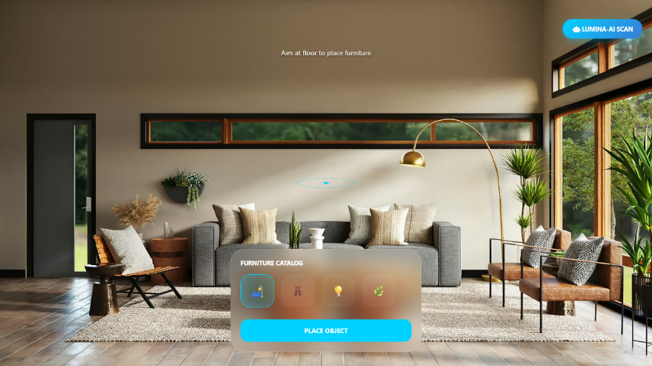
6.Conclusion
This prototype demonstrates a deep understanding of Spatial UX. By moving away from traditional "button-heavy" layouts and towards environmental interaction, the design provides a seamless, professional AR experience.

AR/VR design link: https://interaction-arvr-e73642.netlify.app/

Submitted by: Manju R
Internship Role: UI/UX Intern

